The FastSLAM approach
Consider the case of a mobile robot moving through an unknown environment. The environment consists of a set of stationary landmarks. The position of landmark with respect to some global reference frame is denoted . The robot moves according to a known probabilistic motion model 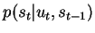, where and denote the robot configuration and the control input at time , respectively. As the robot moves around, it takes measurements of the landmarks in its environment. A measurement is related to the position of a landmark through a stochastic observation model 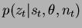, where is the set of all landmark positions and is the index of the particular landmark observed at time .
The SLAM problem is that of simultaneously inferring the location of all landmarks in the environment and the path followed by the robot based on a set of measurements and inputs. Ideally, one would like to recover the posterior distribution 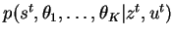, where is the number of landmarks observed so far and the notation denotes 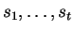(and similarly for other variables). In [16,21], Montemerlo et al. provide a solution in the easier case where the data associations 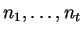are known; that is, their solution infers 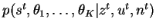.
The key observation underlying the FastSLAM approach is that given a known robot path, measurements corresponding to different landmarks are independent of each other. This is illustrated in figure 1 where the SLAM problem is represented as a Bayesian network. Observe that measurements corresponding to the landmark locations and are only linked together through their joint dependence on the robot path . Using this observation to factor the desired posterior distribution yields
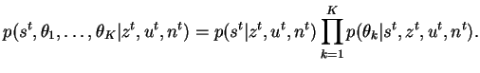 | (1)

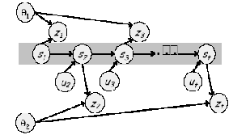
Figure 1: A Bayesian network depicting the structure of the SLAM problem (copied from [16]).
This factorisation decouples the SLAM problem into a path estimation problem and individual conditional landmark location problems. In FastSLAM, a particle filter is used to estimate the path of the robot by maintaining an estimate of its current configuration. Each particle maintains its own estimate of the landmark locations. Because these are conditionally independent of each other given robot path, they may each be maintained by a low-dimensional EKF.
Based on the control input , a measurement and its data association , a FastSLAM update is performed as follows. First, each particle is updated individually. For a particle , this involves updating the local pose estimate 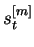by sampling the motion model. The measurement and data association are then used to update the appropriate local landmark location estimate 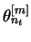using the standard EKF equations. Each particle is assigned an importance weight proportional to the likelihood of the measurement given the estimated robot pose. This quantity is computed in the prediction stage of the EKF. Once all particles have been updated, a new set of particles is generated through importance sampling, which involves drawing samples from the old particle set with a probability proportional to their importance weights.
Assuming the number of particles remains fixed over time and there are landmarks, a naive implementation of this algorithm results in 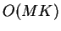time complexity for a SLAM update, mainly because of the importance resampling stage which requires the landmark estimates of a given particle to be copied an arbitrary number of times. The authors show, however, that this complexity may be further reduced to 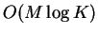. This is achieved by storing the Gaussian landmark location estimates for each particle in tree-like data structures. This transforms the linear time copying operation into a logarithmic time operation which involves modifying a path in the tree. As discussed in section 4, this aspect of the work was not implemented and thus will not be elaborated further here. The reader is referred to [16,21] for a more comprehensive explanation.
The authors propose an extension of FastSLAM to the case of unknown data association. Instead of computing , which requires a marginalisation over data association sequences , they estimate for each particle by standard nearest neighbour gating. 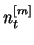then takes the value of the landmark index which maximises the likelihood of the measurement given the local robot pose estimate . If the maximum likelihood is below some threshold, a new landmark is introduced in the map for particle . This process may introduce spurious landmarks in the map. In order to avoid the problems that this may cause, landmarks which are theoretically visible but fail to be observed are removed from the map.
FastSLAM offers many improvements over the traditional EKF-based SLAM framework. In addition to the obvious reduction in computational complexity, the technique intrinsically provides a way of maintaining several data association hypotheses. This is an important advantage, given that a single data association error can cause the EKF-based strategy to fatally diverge. In FastSLAM particles with incorrect data association eventually ``die'' because of their low importance weights, thereby reducing the impact of such errors. Computational efficiency and robustness, however, come at a cost. Indeed, maintaining one map of the environment within each particle leads to the important question of how these maps, should be merged after sufficient exploration. This question becomes especially complicated in the case of unknown data association, where all particles do not necessarily maintain the same number of landmarks. Curiously, the issue is barely mentioned in the original papers.

